MGMT 470: Employee Training and Development
The Workshop Report
Workshop Topic: Email Netiquette for Interns
Under the supervision of
Dr. James Wesley Cooper

Team: Mastery Makers
Sonia Baig, Paulina Tetedje, Odalys Camarena, Vanessa Kho, Kyriaki Nicolaou, Alfina Vahora

May 1, 2025

Abstract
This paper is a summary of the in-class training completed by The Mastery Makers. In this paper we will go over the needs analysis we conducted for the training, the training design and delivery, an explanation as to why we formulated our training as we did, our budget and fund distribution and all our references and sources used in great detail.
We will also conduct an analysis of our perceived effectiveness and critique on our own work.

Part A

Needs Analysis
As individuals move to online working spaces, effective online communication has become the secret to professional success, collaboration, and workplace efficiency. However, the majority of employees, especially new hires, interns, and remote workers, are inadequately trained in the proper online etiquette, and thus communication is affected, as is workplace efficiency. current behavioral gaps include delayed or omitted responses to important messages, use of nonprofessional or obscene language, sending unprofessional content and poorly written emails (e.g., misuse of CC/BCC, informal tone, spelling errors).
Root Causes
- Cultural Differences: Directness or computer manners may be interpreted differently in different cultures.
- Generation Gaps: Boomers and Generation Z differ in language use style and norms.
- Gender Differences: Tone in communication often differs by gender, impacting perception.
Training Gap:
Employees are not always meeting standards for clear, professional, and on-time online communications. Formal training aligned with company standards is required.
Sources and Methods:
- Questionnaires and focus groups for qualitative information
- Measure performance metrics for checking communication errors
- Self-evaluations and documentation reviews for maintaining current practice
Training Objectives
This course assists in constructing digital professionalism through etiquette with the use of emails, videoconferences, and message boards. Overall objectives are to define and enhance professionalism for digital communication, instill a sense of organization, and timing and promote considerate and polite communication within the teams.
Behavioral Objectives:
At the end of the training, interns should be able to:
- Write formal emails with good subject matter, proper greetings, and concise words
- Respond within 24 hours
- Utilizing authorized email templates for formal communications
- Using proper tone and format for 90% of emails (measured by audits)
- Reducing inappropriate sharing of content by 75% in a single quarter
- Practicing good video conferencing manners (e.g., punctuality, utilization of camera, respectful engagement)
The above goals will be supported by interactive role-plays, digital templates, and online learning modules. By focusing on actual-world behavior changes, this training will raise online communication standards and maintain a professional, respectful digital environment.

Program Design Blueprint
For this training we will have a presentation, integrated group discussion and role plays. There will be a brief, engaging PowerPoint presentation to introduce the main concepts of online etiquette. We will also have an interactive discussion and sharing of experiences around online etiquette, particularly focusing on scenarios relevant to interns. Trainees will participate in quick role-playing activities to practice email responses and video meeting behaviors. We will have a short time for participants to ask questions and clarify any doubts about online communication practices. The estimated length of our program is, 1 hour, that is, 45 minutes for the main content and activities, 15 minutes for Q&A and discussions. With this structure we aim to educate our interns on the proper etiquette for online communication. This will facilitate respectful, professional, and effective intern to intern, intern-to-supervisor or manager interaction. We aim to minimize potential misunderstandings and conflicts that ensue because of poor email etiquette.

Resources Needed
The training uses a U-shape seating arrangement, allowing clear visibility of the trainer, encouraging eye contact, and facilitating open discussion. This spatial design supports collaboration and inclusivity, creating a safe environment for asking questions, making mistakes, and experimenting with new behaviors. To design our space for proper learning transfer, it is crucial to have stationary items like pens, pencils and paper to allow for proper notetaking and engagement. Also, we would need a facility with Internet or Wi-Fi, tables and chairs as group activities would require sharing of information across the digital space. We will need a projector and a room with good lightening. We encourage the organization to provide laptops for the training, or to have interns come with their personal laptops, iPad or phones as that would be our tool for group activities. We would also need a timer (this can be supplemented by the facilitator’s phone).

Workshop Trainers
For this workshop, we will require trainers and facilitators. Trainers would have to be professionals with expertise in email communication, workplace etiquette. Trainers are selected based on their expertise in business communication, pedagogy, and email etiquette, ensuring they can adapt their approach to various learning styles and effectively respond to participant questions. We will also require program designers who would be responsible for structuring the workshop delivery and creating a good learning environment. In addition to the above, we will need representatives from the organization’s Human Resource department. They will help tailor the training to the company’s policies and ensure the workshop meets organizational communication standards. IT personnel will be needed to test our training tools (Facilitator’s laptop, projector, sound system) before the training day. They would be required to be on stand-by to offer immediate solutions should there be any technical hitch. Finally, we will need the organization’s interns to be present.

Training Outline/ Agenda
For our training outline or Agenda please see Training Outline/ Agenda in appendix.

Instructional Methods and Theoretical Justification
Trainer-Led Instruction (Mini-Lecture)
This segment introduces the foundational principles of professional email etiquette—tone,
structure, formatting, and clarity. According to cognitive learning theory, direct instruction
facilitates the initial internalization of complex ideas. Paired with discussion, it encourages active cognitive engagement and gives participants an opportunity to ask clarifying questions.
Role-Playing Scenarios
Interns participate in guided simulations of common workplace email situations. This method supports Social Learning Theory (Bandura, 1977), allowing interns to observe modeled behaviors and practice in a low-stakes environment. It also reinforces empathy and situational awareness, essential for crafting sensitive communications.
Group Discussion and Peer Feedback
Following role-play, participants engage in peer discussions. These moments leverage constructivist learning theory, where meaning is constructed through shared dialogue and contextual understanding. Peer feedback boosts motivation and accountability.
Individual Email Drafting Exercises
Interns compose emails based on prompts relevant to their roles. This hands-on task supports experiential learning, bridging the gap between theory and practical execution. Participants receive feedback from the trainer and peers.
Mnemonic Device (E.M.A.I.L)
The acronym EMAIL simplifies and reinforces key communication values. Mnemonics are a proven tool in cognitive psychology to support information retrieval and long-term memory retention.

Training Administration
- Enrollment
The team will communicate the details of the training to potential interns via blackboard, email or in class company. The notice would include the purpose, benefits, and date of training. This could also be an online Qualtrics form where interested interns can sign up to attend the workshop. The deadline for enrolment would be 1 week to training day. The team will send acceptance emails to registered interns along with any necessary pre-training materials and instructions. Ask interns to confirm their participation by a specified date. This can be done through a simple response to the acceptance email. We will send a welcome packet to enrolled interns, including the training schedule, materials, and contact information of organizers for any questions. Also include a brief introduction of the program, outline expectations, provide opportunity for interns to send in any questions they would like answered during the training. We will send regular reminders till training day. Alfina, our Enrolment Specialist, would be the designated contact person
- Course Review and Updates
The team would ensure that the content of our training remains current and relevant by incorporating new trends and insights from the UIC career services. Feedback from trainees would be used to shape our content, allowing for adjustments based on their real-world applications and experiences. The team would do a bi-weekly review of business journals and articles like HBR. This is to keep us updated on industry’s best practices allowing for content quality and effectiveness continually.

Training Evaluation
We will be using the pre-test, treatment and post-test approach. Knowledge checks at the beginning and end of the session allow for measurable learning outcomes. This aligns with Kirkpatrick’s Model of Training Evaluation, focusing on reaction and learning levels. For pre-test, we will have a pre-training evaluation survey with multiple choice questions or True/False gauging trainees’ understanding of the appropriate practices. The pre-test goals for the email etiquette workshop focus on helping participants assess their current communication skills. Before the workshop, trainees reflect on how confidently they write professional and polite emails. The pre-test checks if they understand how to create clear subject lines and use appropriate greetings and closings. It looks at their ability to organize content in a logical and easy-to-follow way. It also assesses whether they can maintain a respectful and professional tone for different audiences. Participants are asked to identify personal strengths and weaknesses. Some may feel confident in grammar but are unsure about tone or clarity. Others might struggle with concise writing or structuring their points. This self-assessment helps trainers see where participants need the most help. It also provides a clear starting point to track progress after the training. Knowing this baseline allows the workshop to target the most important improvement areas. Treatment is where the training takes place. This includes main presentation, introduction of mnemonic device and role-play sessions where interns practice handling different email situations. This will end with a peer review session where interns constructive feedback on each other's emails, promoting collaborative learning. This would test behavior and skill-based outcomes as well as cognitive outcomes.
The post-test goals focus on measuring what participants have learned from the training. After the workshop, the post-test checks if trainees can apply the email etiquette principles they were taught. It looks for improvements in writing clear subject lines and using professional language. It also checks if they can organize the email body effectively and politely. The post-test assesses whether participants avoid common mistakes, such as vague messages or casual tone. It often includes realistic exercises like drafting a follow-up email or replying to a supervisor. Comparing pre- and post-test results shows how much each trainee has improved. It also helps trainers assess whether the workshop successfully strengthened practical skills. The results reveal if participants can apply best practices in real work situations. This comparison offers useful data on how well the training achieved its learning goals.
The feedback process is critical for evaluating the workshop’s success. It gathers both qualitative and quantitative input from trainees. Qualitative feedback asks which parts of the training were most helpful, such as tone, clarity, or structure tips. It also asks what could be improved, like the pacing or the need for more practice exercise. Quantitative feedback asks trainees to rate their understanding of email etiquette on a scale from 1 to 5. It also asks which skills they gained, such as improving clarity or formal tone. Feedback helps trainers understand how participants plan to apply these new skills. It also shows whether the training boosted their confidence in writing professional emails. This combined input helps trainers improve future workshops. It ensures the sessions stay relevant and deliver meaningful results for learners.

Training Materials
Training Materials include a handout on how to create and maintain a professional email signature, see appendix CREATING YOUR PERSONAL EMAIL SIGNATURE. This is a simplified and carefully structured guide. It supplements the training process by allowing participants to follow a step-by-step outline to create their own email signatures. It also shows them how to set default email signatures such that they are better able to integrate this practice in their day-to-day etiquette. Also, the handout contains information on appropriate signature etiquette like when to skip email signatures, and what is considered unnecessary for signatures. The goal is to allow participants to practice with the aid of the manual and training facilitators who would guide them through the process.
To get a good understanding of their learning process, we introduced role play. The roleplay was based on 3 scenarios, accepting a job offer reporting an HR incident, and requesting time off. These scenarios were incorporated into the training to provide participants with realistic workplace situations that require effective communication and professional decision-making. We expect that by engaging in this activity and written exercises, participants developed skills in formal email drafting, ethical reporting, and professional correspondence which are essential competencies for navigating workplace interactions. The activity encouraged critical thinking in handling sensitive issues, such as workplace discrimination and policy adherence, as well as reinforcing the importance of clarity, tone, and structure in business communication. Through these exercises, participants gained practical experience in responding to complex workplace challenges, facilitating a deeper understanding of professional etiquette and the impact of communication in organizational settings. The expected learning outcome is improved confidence, efficiency, and adaptability in workplace interactions, preparing individuals to handle various real-world scenarios with professionalism and strategic thinking.

Workshop Summary
The email netiquette workshop was conducted to enhance professional email communication skills and was targeted at interns. Facilitated by the Mastery Makers, the session took place on 4/24. The session was designed to address common mistakes in email communication and promote clarity, professionalism, and effectiveness in written correspondence. The workshop began with a short pre-test through Google Form to assess participants’ initial comfort levels and knowledge about email writing. Then, we had a brief presentation using slides to introduce essential concepts. The concept that was highlighted was the mnemonic device EMAIL, a five-step strategy developed to help remember the core components of effective communication. It stands for Ensure clarity, Maintain professionalism, Avoid overloading, Include Key details and Leave a signature. The mnemonic device was referenced throughout the session to reinforce learning. Participants also engaged in a scenario designed to apply the mnemonic device in context. The scenarios included reporting an HR issue and requesting time off. They were asked to write a sample email and share their drafts to receive feedback from us and peers.
In addition to the activities, participants received printed handouts and a step-by-step guide on how to create a professional email signature. This included tips on what to include full name, title, contact information, and optional pronouns), formatting advice, and sample signatures for reference. We emphasized that a consistent and well-crafted email signature enhances credibility and professionalism. The session concluded with an open Q&A and a post-training assessment through Google Form. This post-test asked them to reflect on how comfortable they felt writing professional emails after the training and asked them to rate their understanding of the topics covered.

Summary Statistics
Before training, participants rated their confidence in workplace communication. Their ratings showed moderate confidence, but responses varied. Writing to recruiters had the lowest average score (3.5) with the highest variability (0.97), indicating uncertainty in structuring emails for external communication. Qualitative feedback revealed concerns about clarity, formatting, and professionalism. After training, participants showed significant improvement. All measured skills averaged 4.875, with a lower standard deviation (0.33). We observed higher and more consistent confidence across all areas. Participants provided positive feedback, indicating that the interactive exercises, role-playing, and practical applications, helped reinforce their learning. The training was effective in boosting confidence and communication skills. However, relying only on digital forms for evaluation led to lower response rates, limiting the data collected (16 post-test responses vs. 20 pre-test responses).
Part B: Personal & Group Assessment

Individual Assessment of Training

Individual Analysis Alfina
The most effective part of the training workshop was the core concept itself. It is highly relevant for interns and college students who are preparing to enter the workplace. Learning proper email etiquette is essential for professional communication. The workshop successfully addressed this need. The scenarios used during the sessions, such as accepting a job offer or discussing sensitive information with HR, were particularly realistic and relatable. These examples helped participants connect the lessons to real-world situations. They allowed learners to practice in meaningful contexts. This reinforced the importance of clarity, tone, and confidentiality in email writing.
There was nothing in the workshop that stood out as least effective. The activities were consistently engaging, and participants stayed involved throughout. Based on the participants’ evaluations, it was clear they understood the key components of writing effective emails. These included maintaining proper tone, conciseness, clarity, and confidentiality. Most participants showed a good grasp of the concepts. Only a few minor mistakes needed improvement. For future sessions, one thoughtful recommendation is to add more interactive activities, such as using a tool like Kahoot. This would increase participant engagement without requiring them to go back and forth between opening emails and writing long messages to trainers. Aside from this, the workshop was highly effective and well received.

Individual Analysis Paulina
One of the most effective elements of the training was active engagement with participants, particularly during hands-on activities. Facilitating real-time discussions allowed participants to ask clarifying questions and deepen their understanding. The interactive approach was especially beneficial in guiding participants through creating their professional email signatures, as it provided personalized support based on their varying levels of experience.
A notable challenge was the reliance on digital evaluation forms for gathering participant feedback. Despite an attendance rate of 30 to 40 participants, only 21 pre-test responses and 17 post-test responses were collected. This suggests that some attendees faced barriers in accessing the forms, whether due to lack of a device, internet issues, or simply missing the prompt to complete them. Another observation was that participants demonstrated different levels of comprehension, with some navigating the handouts independently while others required a more structured, instructional approach. This emphasized the importance of adapting facilitation methods to suit a range of learning styles. The activity reinforced how customized guidance improves engagement and knowledge retention. To my point, I would recommend supplementing digital forms with print copies in future training to ensure higher response rates and mitigate technological barriers. Also, the organization could offer flexible facilitation approaches, allowing for both independent learning and direct instructor support based on participant needs. Finally, I would encourage real-time engagement during exercises to help participants actively apply concepts and receive immediate feedback.

Individual Analysis Sonia
The most effective part of the training workshop, from my perspective, was the group activity session that included role-play and the creation of DIY email signatures. As a co-facilitator for this segment, I found it rewarding to see how engaged the participants became when they were given the opportunity to apply the email etiquette principles in a creative and interactive format. These activities not only helped reinforce the importance of clarity, tone, and format in professional emails, but they also encouraged teamwork and discussion among the interns. The hands-on approach helped bridge the gap between theory and practice, making the training feel relevant and applicable to real-world workplace situations.
Overall, the workshop flowed well, and all sections tied together effectively. However, one potential improvement could be to incorporate brief knowledge checks or gamified tools like Kahoot throughout the session to maintain energy and provide instant feedback. This would enhance engagement without adding extra pressure on participants. Despite this, the feedback we received showed that the interns understood the key concepts, and I was pleased to see minimal confusion or errors during the activities. The training was a great learning experience for both facilitators and participants, and it successfully met its objectives.
Individual Analysis Odalys
I believe what was most effective about the training was the practice in small groups. I am a firm believer that we learn things better once we practice them and understand how they can be applied in day-to-day life. I also think that getting live feedback as a class was a nice way to understand what our own strengths and weaknesses are in a fun and lighthearted way. The trial-and-error mentality created an environment where the class was encouraged to try but also was aware of the safety net they had cast below them. What I would deem as ineffective would be the mnemonic device we chose. We forced it a bit too hard, and I think if we had more time to do more extensive research we could have found or created a much better device. I do not think it was as catchy or memorable as we all had hoped but it still drove the point home. It was, however, very rewarding to read all the 4- and 5-star ratings when it came to the ease of understanding of the training and whether the participants felt they were gaining something valuable. We received some lovely comments about the overall training, and it was a nice experience to know people weren't bored or disinterested in the presentation and practice time.
If we were to do this training over again, I would modify our mnemonic device and perhaps show more examples potentially from the first round to show more realistic effective and ineffective examples in our presentation. I would also find a way to get the audience more engaged. Instead of just telling them our mnemonic device I’d fish for answers and see if the group would guess some of what we had planned to demonstrate. Overall, I am quite content with how our feedback showed how effective we were.

Individual Analysis Kyriaki
One of the most effective aspects of our email etiquette training was the structured mnemonic device “EMAIL” (Ensure clarity, Maintain professionalism, Avoid overloading, Include key details, Leave a signature), which helped participants internalize best practices in a memorable way. This approach simplified complex communication principles and made them accessible, especially for interns with limited professional email experience. According to the participants’ evaluations, 90% reported feeling more confident in their ability to write professional emails after the session. However, one area that proved less effective was the limited time allocated to hands-on role-play activities. Several attendees noted in their feedback that they would have benefited from more practice scenarios to apply what they learned. Based on these insights, I recommend increasing interactive segments in future workshops and providing more individualized feedback during exercises to enhance skill application and retention. As trainers, it is our responsibility to adapt and improve based on participant needs and learning preferences.

Individual Analysis Vanessa
The most effective part of the training workshop was the scenario-based writing activity. I think it allowed participants to apply the mnemonic device in a realistic professional situation. The hands-on approach helped reinforce the training content and made the session more practical and engaging. I also think that we executed everything very smoothly and there was not anything that was necessarily ineffective. Participants’ evaluations were mostly positive. In the post-test, many people said they felt more confident writing professional emails and enjoyed the writing activity. Overall, the feedback was positive and showed that the training met its key learning objectives. If I were to conduct another workshop again, the one thing I would do is to prepare printed pre and post-tests. Due to internet problems, some participants were unable to complete the google form and we did not have printed backups. This limited our ability to fully assess the workshop’s impact. Despite this challenge, I think we still gathered a relatively good amount of feedback.

Group Assessment and Conclusion
The training was engaging and well-structured, making it easy for participants to grasp key concepts. Through a co-constructive learning approach, participants actively built their understanding of workplace communication, particularly professional email etiquette. They explored how to craft emails that are succinct, clear, and ethically sound, applying best practices in real-world scenarios. Additionally, the training incorporated adult learning principles, leveraging participants’ prior knowledge and experiences to deepen their comprehension.
One challenge identified was the difficulty in recalling mnemonic devices, as the adjectives introducing them (Ensure, Maintain, Avoid, Include, Leave) made them harder to remember. This could be addressed by integrating mnemonic devices into practical application exercises, such as a group writing activity, reinforcing their use in real-time scenarios. Another key strength of the session was the assessment approach, which proved effective due to the compact group sizes. With six groups ranging from 3 to 6 members, facilitators were able to review sample emails in real time, fostering peer learning through group discussions and feedback sessions.
While this format worked well, scaling it to larger groups (60+ participants) could present challenges, as time constraints might limit thorough feedback for each team. To maintain effectiveness in future sessions, alternative evaluation methods, such as targeted feedback rotations or structured peer reviews, could be explored. This would ensure participants continue to benefit from detailed assessments while accommodating a larger audience. Overall, the training was successful in enhancing workplace communication skills while highlighting valuable insights for refining future sessions.

References
Hafla. (2023). Workshop material and supplies checklist. Hafla, Accessed on February 20, 2025 from https://www.hafla.com/blog/workshop-material-and-supplies-checklist/
Half, R. (2024, November 25). Email signature etiquette: The good, the bad and the unnecessary. Robert Half. https://www.roberthalf.com/us/en/insights/career-development/email-signature-etiquette-the-good-the-bad-and-the-unnecessary#:~:text=This%20email%20signature%20includes%20only%20partial
Hambridge, S. (1995). RFC 1855: Netiquette guidelines. Internet Engineering Task Force. https://www.rfc-editor.org/rfc/rfc1855
Purdue University. (2024). Email etiquette. Email Etiquette - Purdue OWL® - Purdue University, Accessed on February 20, 2025 from https://owl.purdue.edu/owl/general_writing/academic_writing/email_etiquette.html
Kirkpatrick, D. L., & Kirkpatrick, J. D. (2006). Evaluating training programs: The four levels (3rd ed.). San Francisco, CA: Berrett-Koehler.
Knowles, M. S., Holton, E. F., & Swanson, R. A. (2015). The adult learner: The definitive classic in adult education and human resource development (8th ed.). New York, NY: Routledge.

Appendices

Training Outline/ Agenda
Activity | Time (minutes) | Person Responsible
Introducing facilitators and Training Topic and objectives | 3 | Kyriaki
Pre-Poll + mini class discussion on interns’ personal experiences  Goal: Get to know our interns and their current level of understanding on the topic | 10 | Kyriaki
What is good Email Etiquette, Introducing the Email Approach (Mnemonic device) | 2 | Paulina
Expanding on the ways to ensure good email Etiquette | 5 | Sonia, Paulina
Sample of Good vs Bad Email Etiquette |  | Vanessa
Group activity (Role play, DYI email Signature) | 20 | Odalys, Paulina
Discussions: Sharing what groups wrote, giving group feedback and corrections | 15 | Odalys
Summary of training, mnemonic device, conclusion and post-poll | 5 | Alfina
8- different sections | Total: 60 mins (1hr) | 6 facilitators

CREATING YOUR PERSONAL EMAIL SIGNATURE
Outlook Interface
- On the View tab, select View Settings.
- Select Accounts
- Select Signatures.
- Select New signature, then give it a distinct name.
- Enter a name for your signature (Personal Brand? Any name)
- In the editing box below the new name, type your signature, then format it with the font, color, and styles to get the appearance you want.
Signature should have your Legal Full Name
Pronouns(optional)
Position
Company
Contact Info (Phone| Alternative Email)

- Select Save when you're done.
- With your new signature selected from the list above the editing box, go to Select default signatures and choose to apply the signature to new messages and no signature to replies and forwards.
- Select Save.
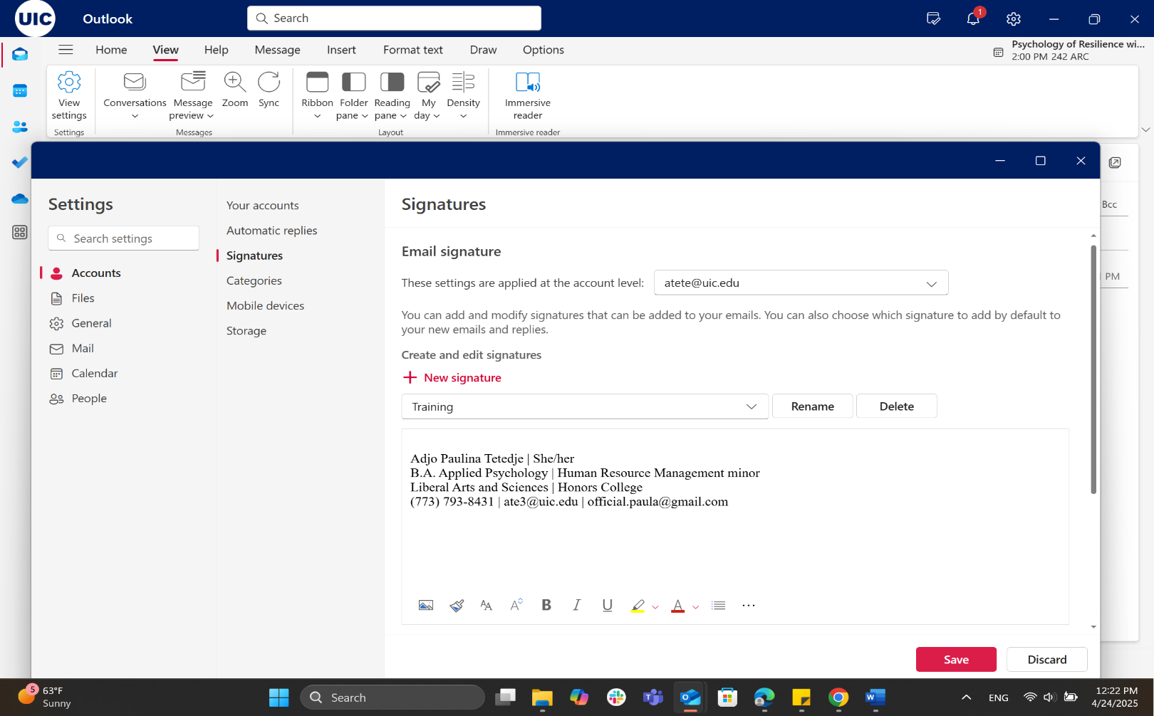







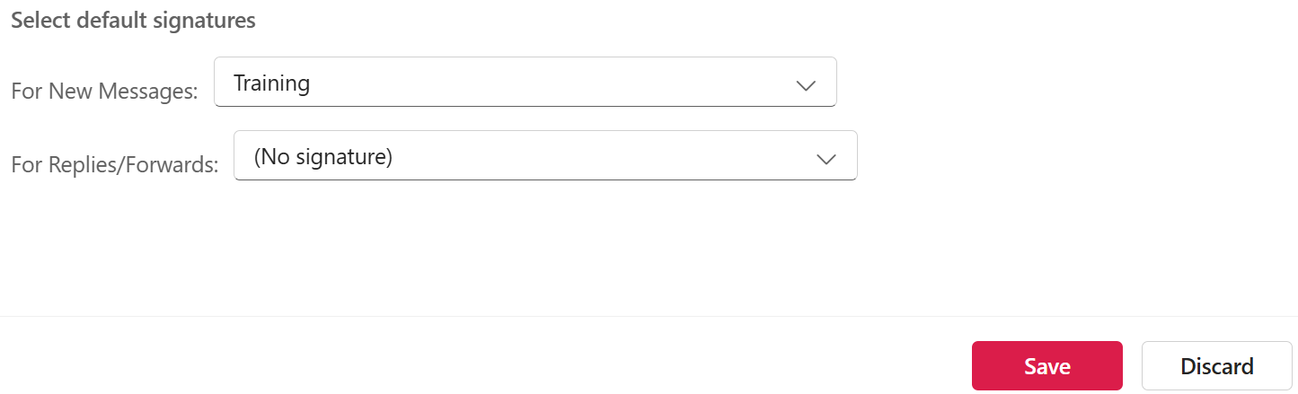
When to skip the signature
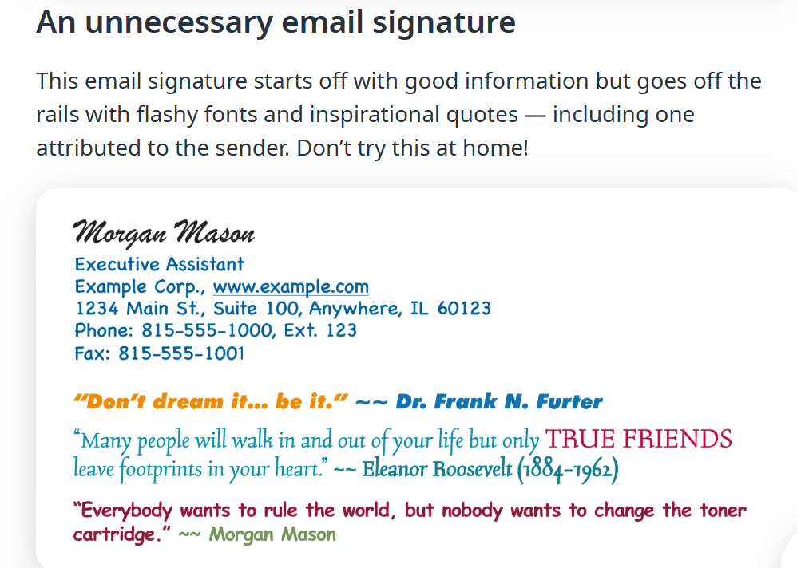
Once you’ve exchanged a few emails with someone, it’s good etiquette to remove your signature from the thread.
Remember THE EMAIL APPROACH
E – Ensure Clarity
M – Maintain Professionalism
A – Avoid Overloading
I – Include key details
L – Leave a Signature
HOPE YOU ENJOY YOUR TIME WITH US!

Roleplay scenarios
Scenario #1 Accepting a job offer
Imagine you are a fresh graduate who has been interviewing like crazy to get their dream job. After weeks of anticipation, countless “I am sorry to inform you” emails and many more lightly threatening emails from your student loans, you finally get the email with a job offer!
How would you respond back to the hiring committee of XYZ company after they send you your offer letter?
Remember The EMAIL APPROACH
Scenario #2 Reporting an HR incident
Imagine you were on your way to lunch minding your business when you overhear two hiring managers discussing one of your coworkers. They are making remarks about their application saying they would never be able to get the job because they are a woman. They laugh and make more derogatory marks about her from her appearance and about her having kids. How would you write an email to your HR department to report it.
Scenario #3 Requesting time off
Imagine you are planning your yearly vacation. You have decided on a 2-week out-of-the-country vacation. You are going to your dream destination and are super excited to have the budget and opportunity to go. How would you write an email to your boss to ask for the time off?

Scenario Feedback from Group

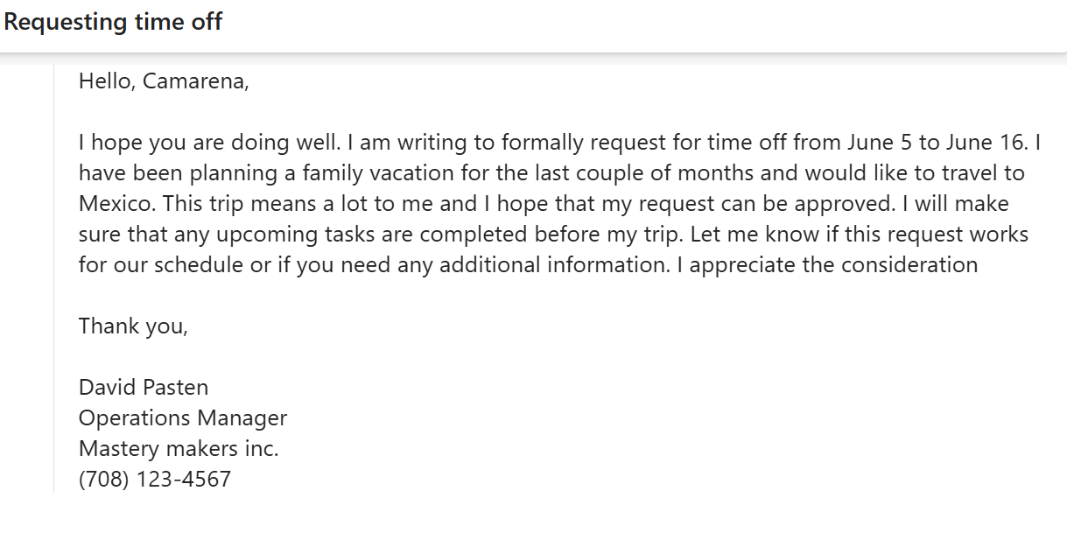
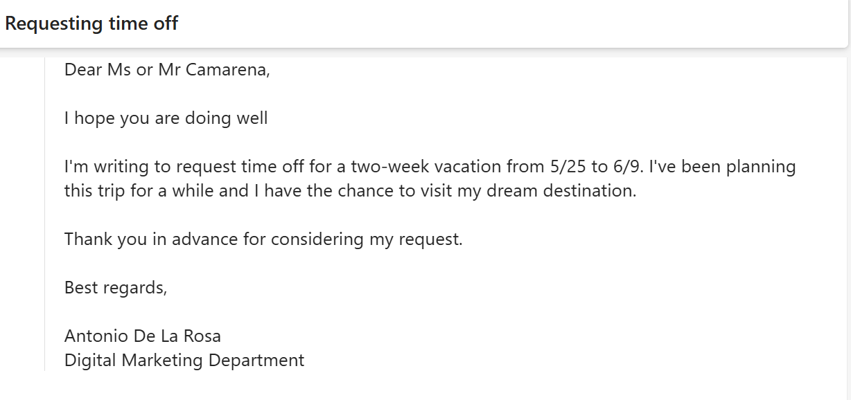

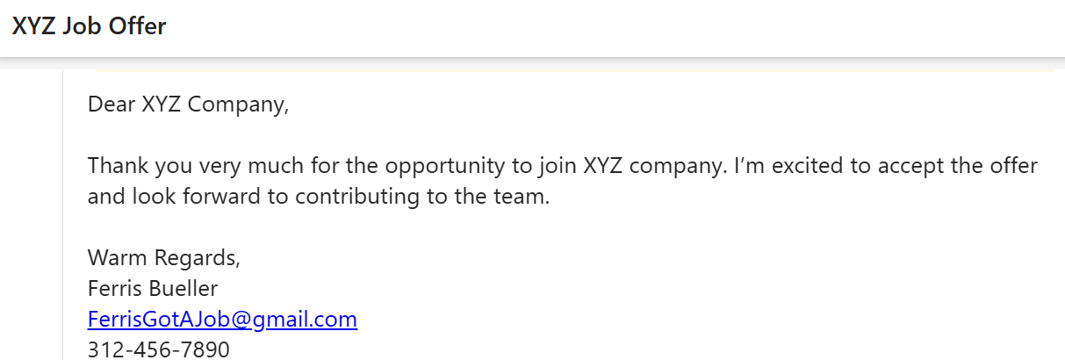
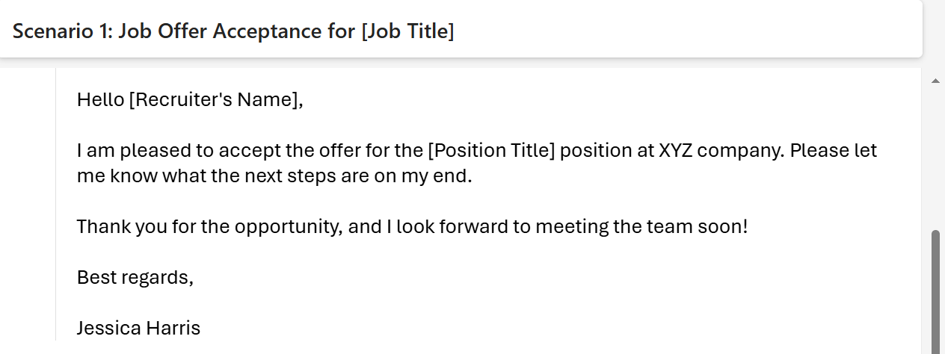

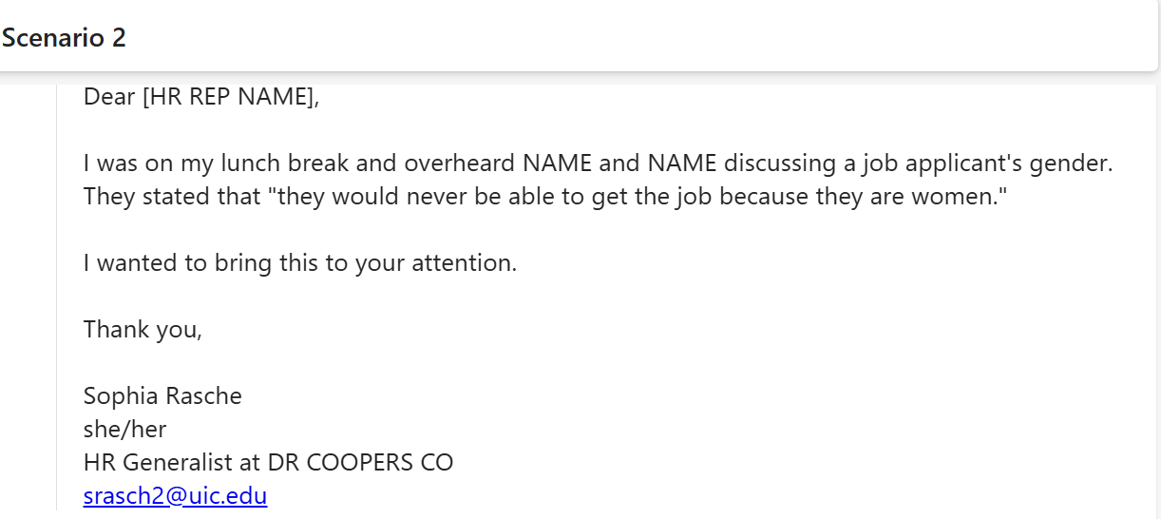

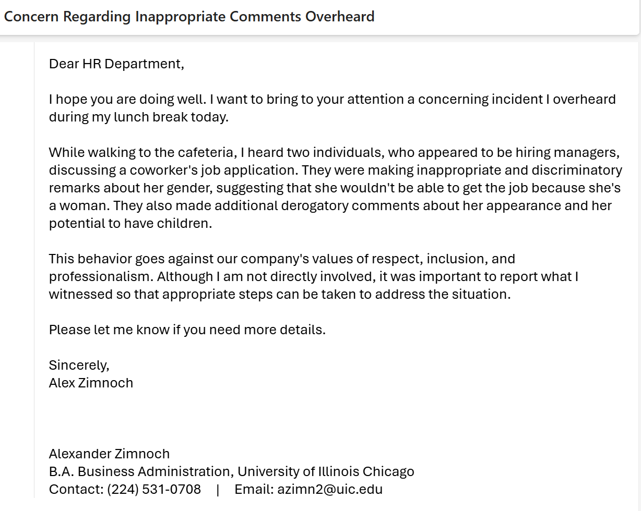
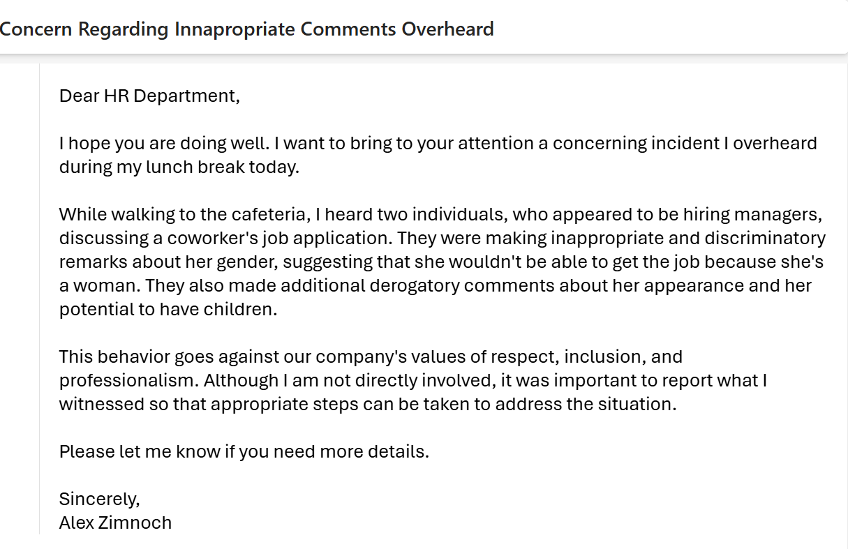

Fig 2

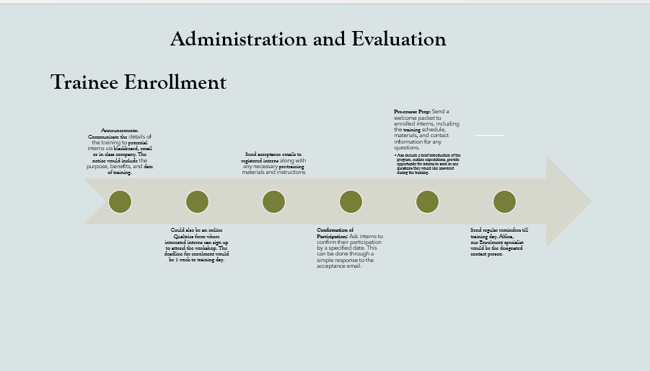
Fig 3: Training slide deck
The full slide deck is accessible at Employee Training Presentation.pptx or Email Etiquette Training for Interns Presentation.pdf

Part B- Evalutation
Data from Pre+Posts tests
Pre-tests
https://docs.google.com/forms/d/e/1FAIpQLSct4Y4X1g4Kn46EajkytlJk5-CniqVYRdHjgVYyN8I2tWzVAQ/viewform?usp=header
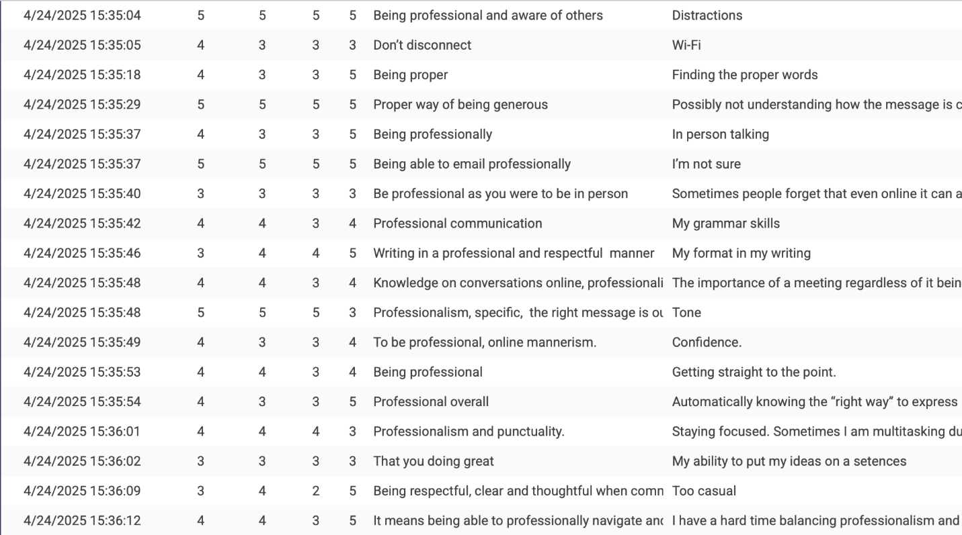
Post-Tests
https://docs.google.com/forms/d/e/1FAIpQLSer9MxPMf8nir2cIVAbLS6kjRkceicD1E29Xsry8dlr3TzD0Q/viewform?usp=header
